

Fof量化投资交易管理系统

**Quantitative Investment Transaction**

**Management System of FOF**

**PC端应用用户手册**



**PC User’s Manual of Application**

——2016届“花旗杯”金融创新应用大赛

Contents

1． About this manual 3

2． Software Overview 3

3．Utility Guide 3

3.1 Client Administrator 3

3.1.1 Install ‘The quantitative investment transaction management system of FOF’ PC client 3

3.1.2 Login for administrators 3

3.1.3 Check the system logs 3

3.1.4 Management of account 4

3.2 Normal users of client 4

3.2.1 Install ‘The quantitative investment transaction management system of FOF’ PC client 4

3.2.2 Login for normal users 4

3.2.3 Newly build FOF combination 5

3.2.4 Check the market quotation 7

3.2.5 Check information of single fund 8

3.2.6 Real time monitoring of FOF production 9

3.2.7 Clients view the profit and losses of FOF production 10

3.2.8 Clients view the statistical report of FOF production 11

3.2.9 Clients view the performance attribution of FOF production 12

3.2.10 Clients view the property allocation of FOF production 12

3.2.11 Clients view the position alteration records of FOF production 13

3.2.12 Clients view the performance estimation of FOF production 13

3.2.13 Clients adjust the proportion of FOF production 14

3.2.14 Clients adjust the parameter 15

3.2.15 Clients view the risk-controlling information 15

4. Parameter and partial Concept Description 16

4.1 alpha 16

4.2 beta 16

4.3 Sharpe ratio 16

4.4 Treynor Index 17

4.5 Jensen’s Performance Index 17

# About this manual

This manual is User’s manual of application in PC of the ‘The quantitative investment transaction management system of FOF’. It demonstrates how to use this software and explains some parameters in detail.

# Software Overview

The quantitative investment transaction management system of FOF contains two parts, client and server. Server offers the FOF maker service to provide FOF management, risk management and user management. Client designs FOF combination for investors in order to help them manage FOF production dynamically. The investors can also check the market quotation and history data.

# 3．Utility Guide

## 3.1 Client Administrator

### 3.1.1 Install ‘The quantitative investment transaction management system of FOF’ PC client

Obtain the installation package of the PC client and unpack it.

### 3.1.2 Login for administrators

Double click the ‘.jar’ file in the Installation directory. Then the client starts and shows a graphical login. The administrator can input his or her user name and password, then the system will jump to the interface of account management. As shown in the following figure：

### 3.1.3 Check the system logs

The administrator clicks the ‘check the system logs’ button in the navigation bar. The system shows the system logs. As shown in the following figure：

### 3.1.4 Management of account

The administrator clicks the ‘account management’ in the navigation bar. The system shows all the information of the account, including password and user name. The administrator can add or delete the accounts. As shown in the following figure：

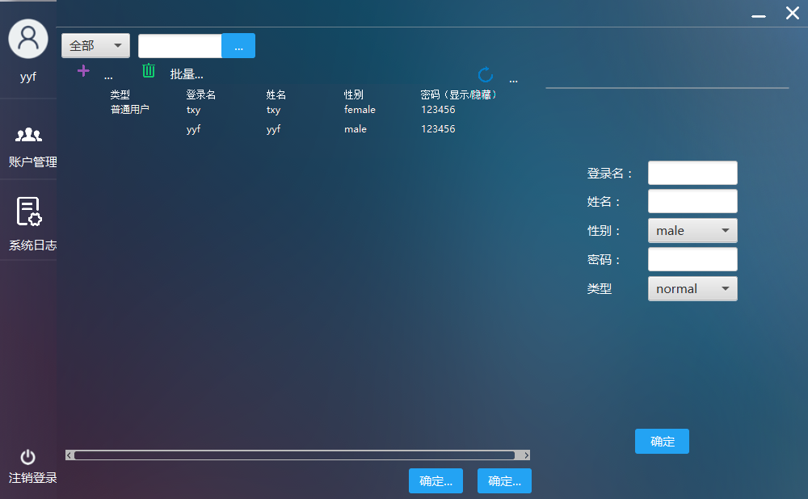

## 3.2 Normal users of client

### 3.2.1 Install ‘The quantitative investment transaction management system of FOF’ PC client

Obtain the installation package of the PC client and unpack it.

### 3.2.2 Login for normal users

Double click the ‘.jar’ file in the Installation directory. Then the client starts and shows a graphical login. The user can input his or her user name and password, then the system will jump to the interface of building initial FOF combination.

### 3.2.3 Newly build FOF combination

If the user logins for the first time, the system will enter in the newly build FOF combination. The user can click the button and start to build his or her own FOF combination. As shown in the following figure：

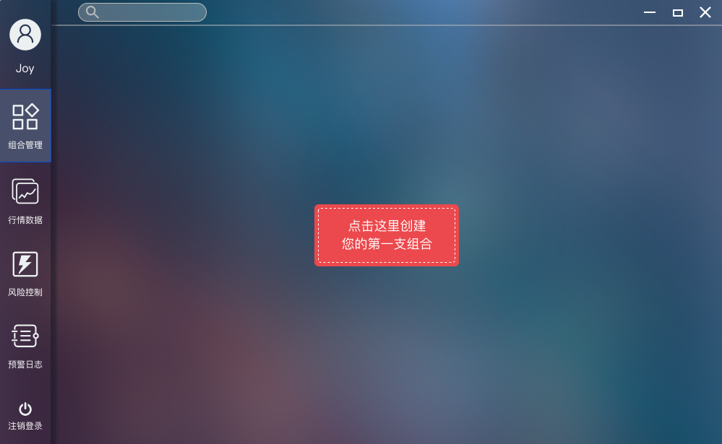

Settings for user preference:

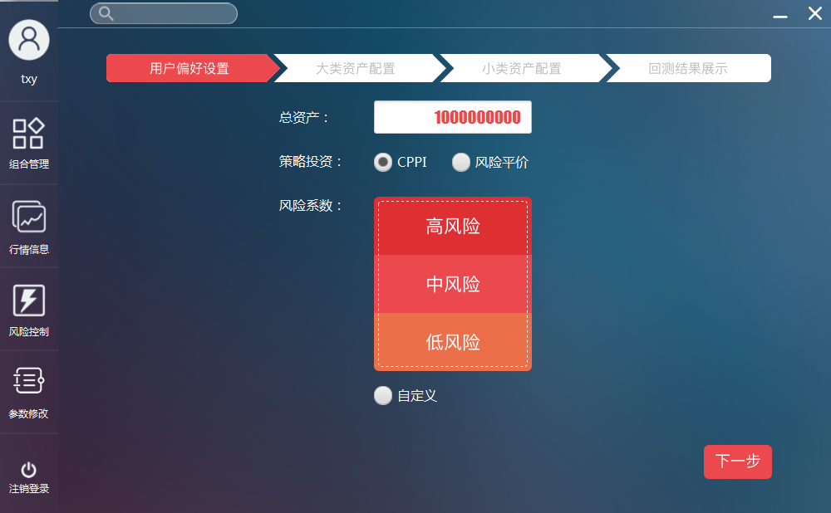

The user can allocate his or her assets. Click the next, the system shows the general asset allocation.

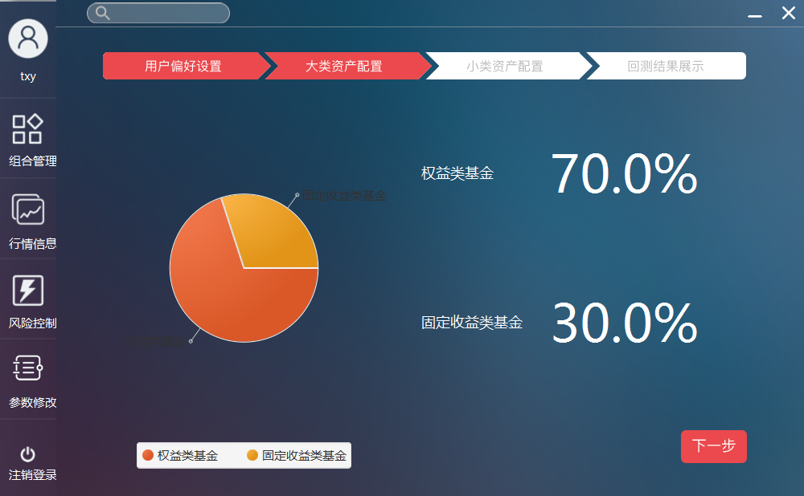

Click next to check the asset allocation in detail.

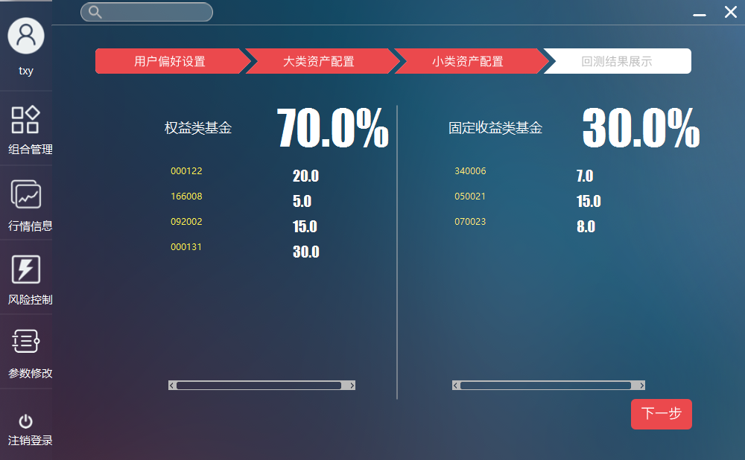

Click next to check the back-trace result. The user can name his or her combination. After clicking finish, a FOF combination has been built successfully.

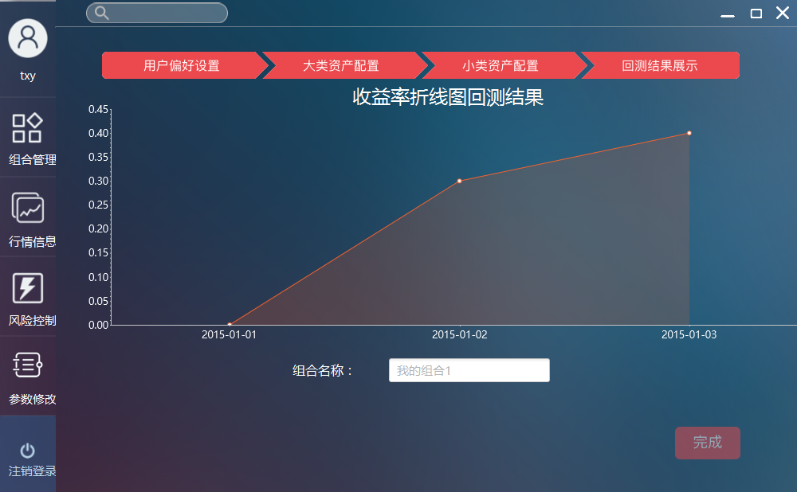

### 3.2.4 Check the market quotation

The user clicks market information in navigation bar. The system shows the market quotation. The user can click the button on the top to choose the fund type. As shown in the figure, you can see basic information of the funds. After clicking the single fund, the system shows you its trends of net worth and profit. After double-clicking the single fund, you can enter an interface of specific fund information.

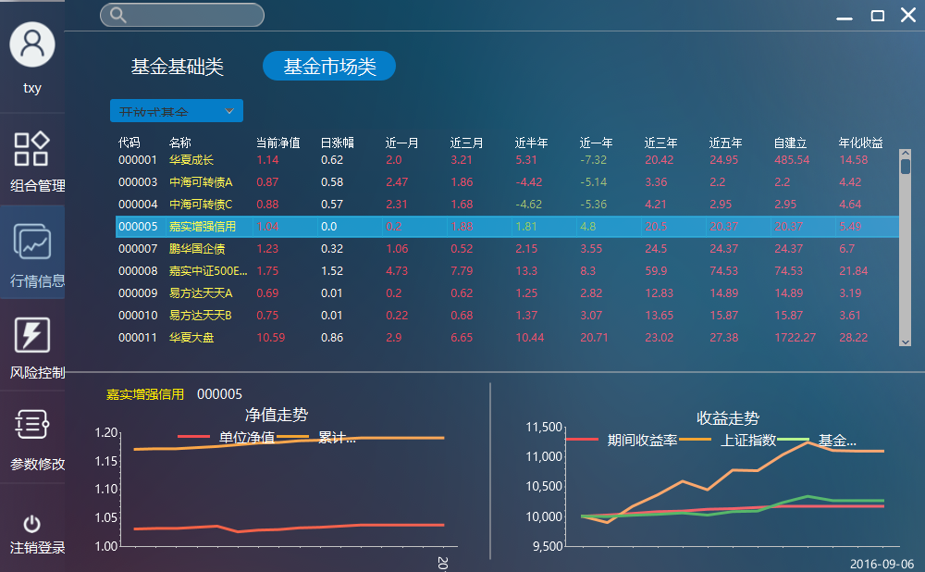

You can select fund type on the top.

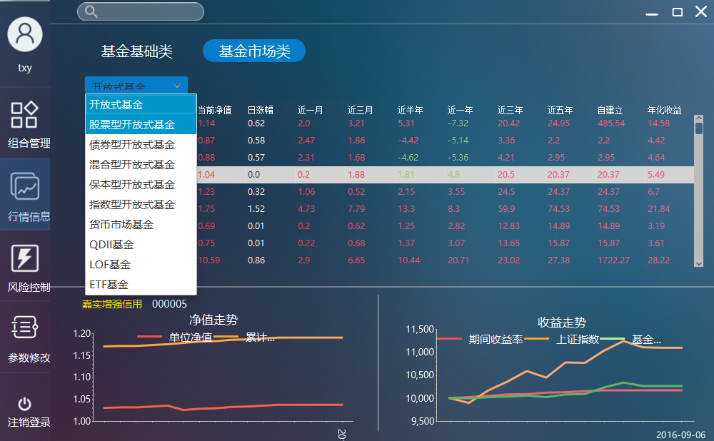

### 3.2.5 Check information of single fund

There are two ways for user to check the information of single fund. The first way is double-clicking the single fund in the interface of market information. The second way is searching fund name in the search bar. Below the bar you can see the results of fuzzy search. Click one of the lines you can enter the interface of single fund. The search result is shown in the following figure:

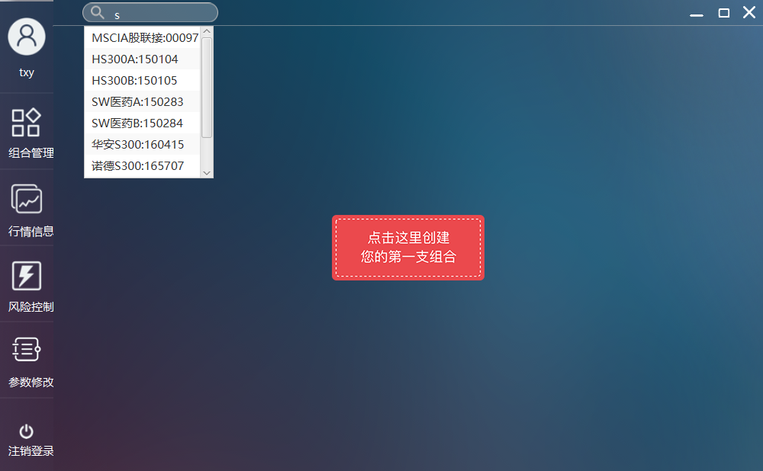The interface of single fund shows the basic information, earning rate, performance, asset allocation and performance appraisal.

In the performance, you can check the Million wave chart and the Discount premium rate. In the asset allocation, you can also check the distribution, stock fund, shares and industry allocation.

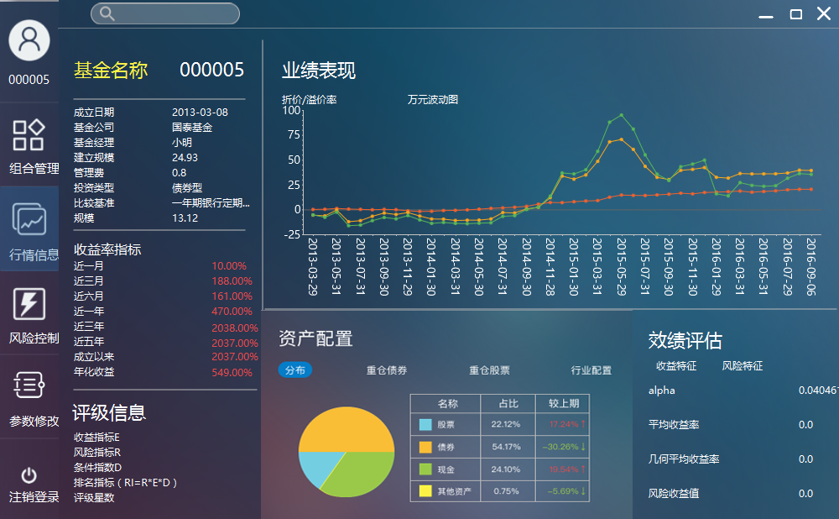

### 3.2.6 Real time monitoring of FOF production

Click the FOF management in the navigation bar. As shown in the following figure:

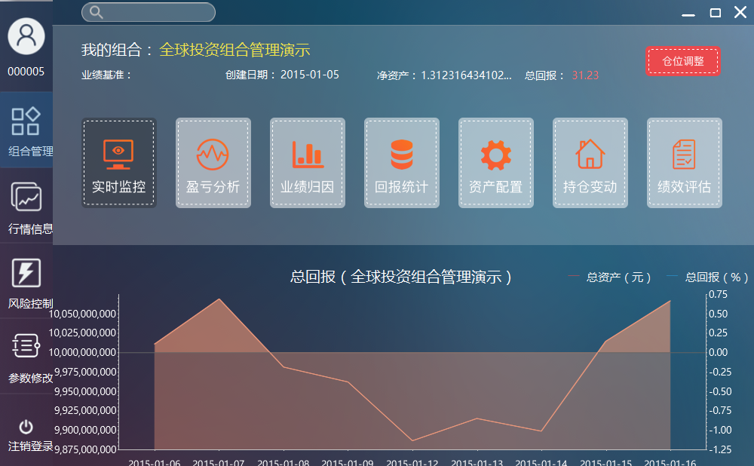

Click the real time monitoring button. As shown in the following figure:

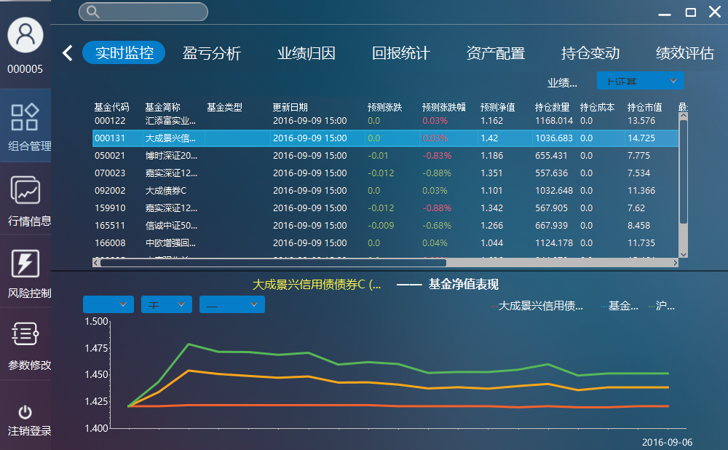

You can select performance benchmarks at right. After clicking the single fund, you can see its net worth. You can select the net worth type(right, unit, total) and period.

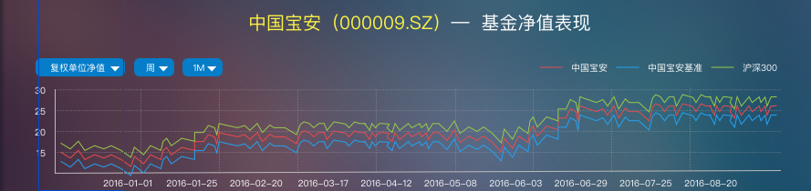

### 3.2.7 Clients view the profit and losses of FOF production

The system will jump to profit and losses analysis view after users click the button on viewing the profit and losses in FOF management view. Users can choose the analysis range and the base of the achievement, to get information about the profit and losses of FOF production in various perspectives. As shown below:

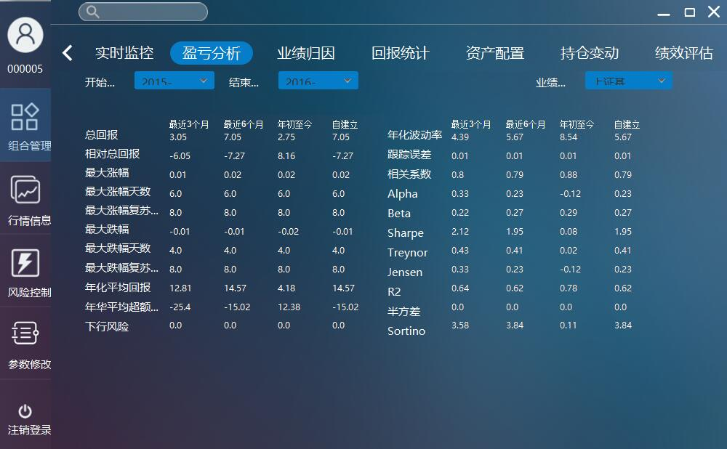

### 3.2.8 Clients view the statistical report of FOF production

The system will jump to statistical report view after users click on the button on viewing statistical report in FOF management view. Users can choose the range of the statistical, the cycle of doing statistics and the cycle of report, to view the statistical index of FOF production in selected range as well as bar chart on return-back rate. As shown below:

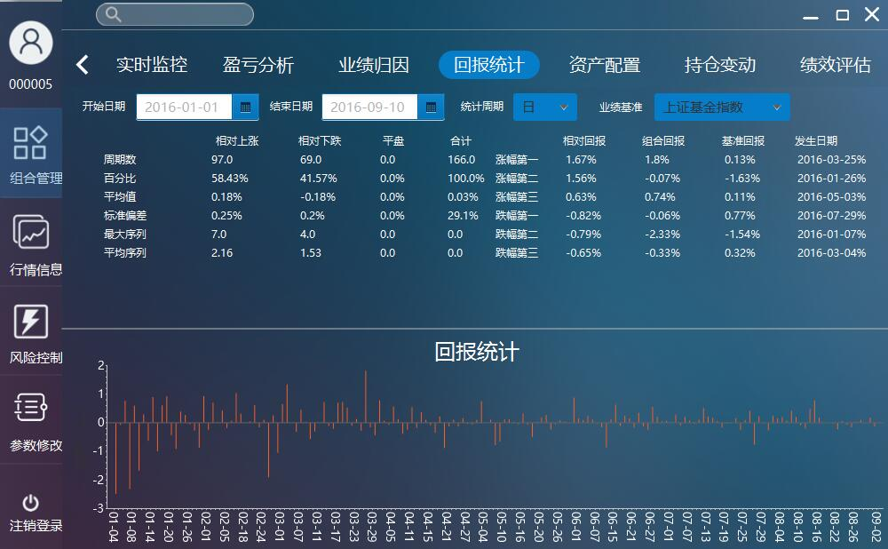

### 3.2.9 Clients view the performance attribution of FOF production

The system will jump to performance attribution view after users click on the button of viewing the performance attribution. Users can choose the time range of the statistical, the category of property. and the cycle of report. After clicking on a specific fund, the client will show fundamental information of this fund, aiding users to analyze the performance of FOF production. As shown below:

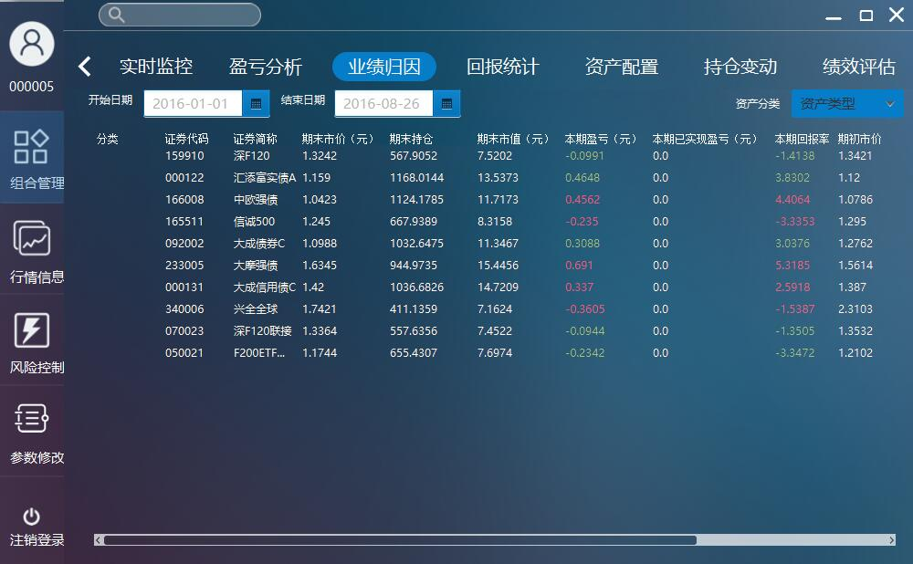

### 3.2.10 Clients view the property allocation of FOF production

The system will jump to property allocation view after users click on the button of viewing the achievement analysis. Users can choose the time range of the statistical, the category of property. and the cycle of report. After clicking on a specific fund, the client will show fundamental information of this fund, aiding users to analyze the performance of FOF production. As shown below:

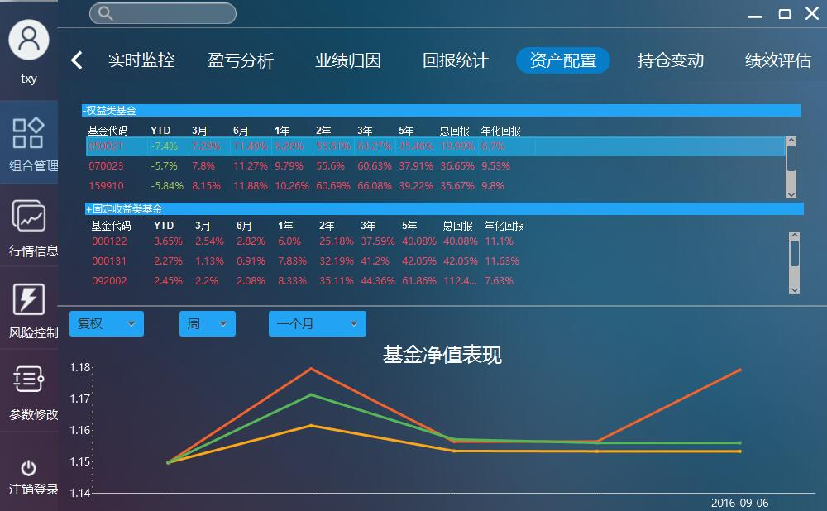

### 3.2.11 Clients view the position alteration records of FOF production

The system will jump to position alteration view after users click on the button of viewing position alteration records. Users can check the records of adjustment of position.

### 3.2.12 Clients view the performance estimation of FOF production

The system will jump to performance estimation view after users click on the button of viewing performance estimation. Users can choose to view the indexes of risk or the style of investment. As shown below:

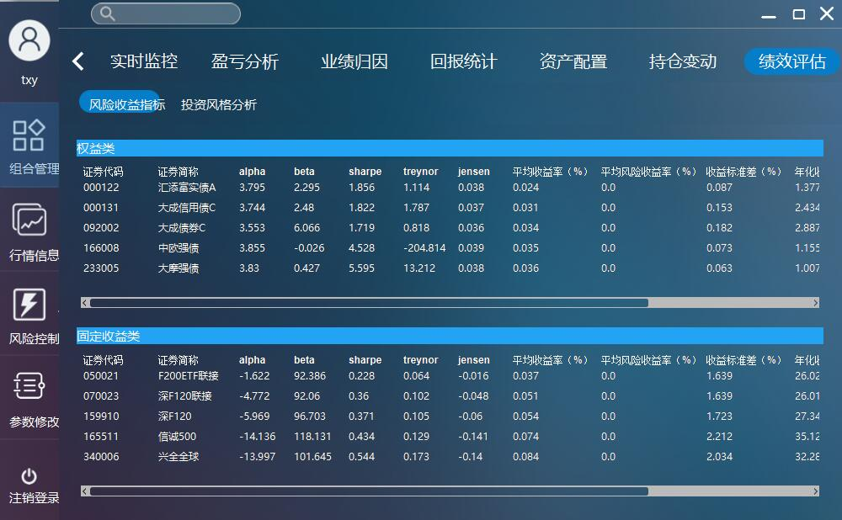

### 3.2.13 Clients adjust the proportion of FOF production

Users can adjust the proportion of FOF production after clicking on the button of proportion adjustment. Users can drag the slide block to adjust the proportion of one particular fund. After click the confirm button, the newly-produced FOF production will be saved by the system. If the user enters invalid value, the system will prompt the user to reenter another value. As shown below:

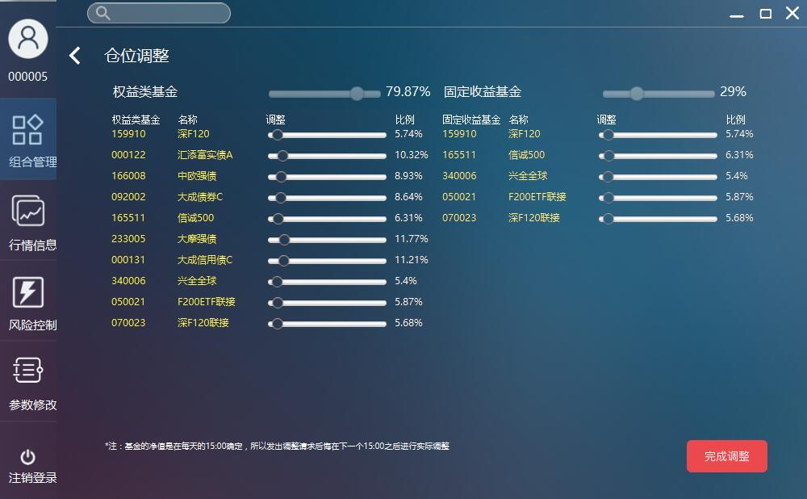

### 3.2.14 Clients adjust the parameter

Users can adjust the parameter after clicking on the button of parameter adjustment. After clicking on the confirmation button, the system will save the new parameters. As shown below:

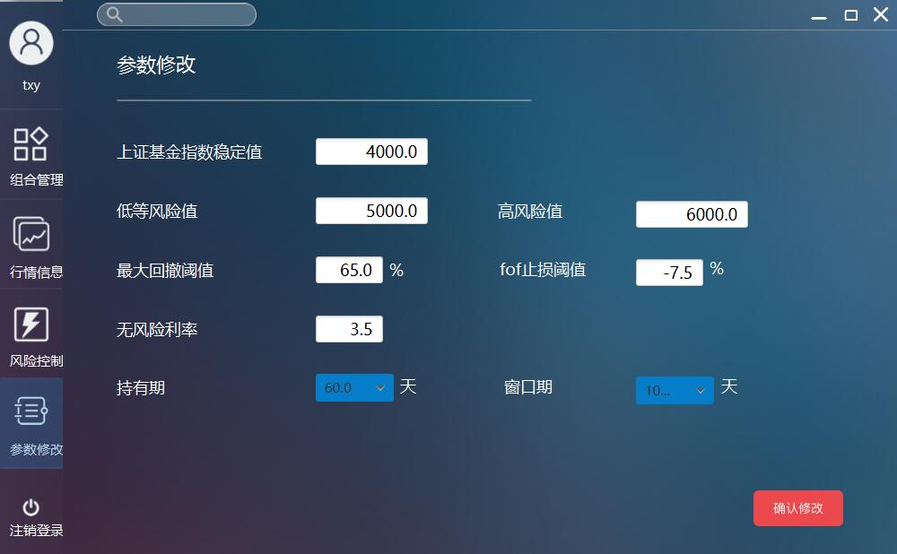

### 3.2.15 Clients view the risk-controlling information

Users can check risk-controlling information after clicking on the button of risk control. Users can view the records of parameter adjustment and historic close price and profit in line chart form.

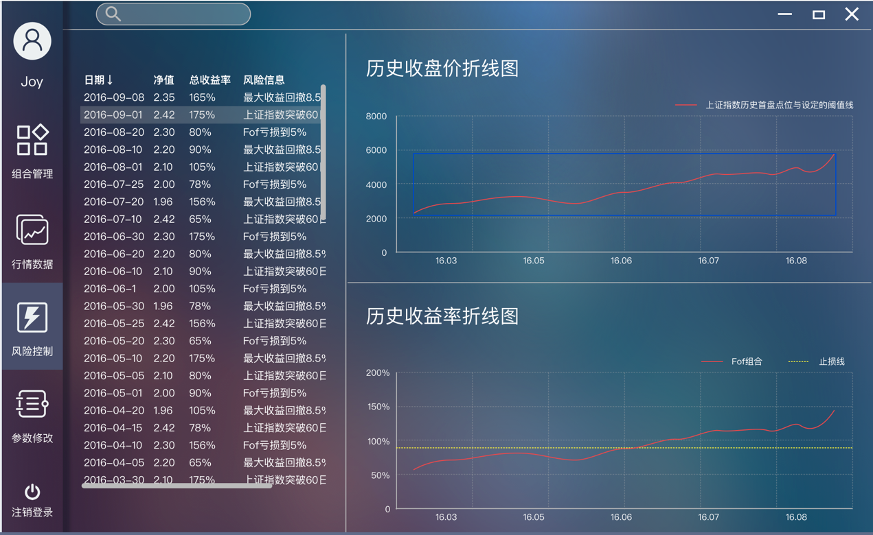

# 4. Parameter and partial Concept Description

## 4.1 alpha

Alpha coefficient is difference between the absolute return of investment and fund and the expected-risk return calculated via beta coefficient. To be simple, alpha coefficient is the difference between authentic risk return and the average expected risk return.

## 4.2 beta

Beta coefficient is a risk index, using for evaluating the price fluctuation of specific stock or fund compared with the market. Beta coefficient is a tool for assessing the systematical risk of fund.

## 4.3 Sharpe ratio

In finance, the Sharpe ratio (also known as the Sharpe index, the Sharpe measure, and the reward-to-variability ratio) is a way to examine the performance of an investment by adjusting for its risk. The ratio measures the excess return (or risk premium) per unit of deviation in an investment asset or a trading strategy, typically referred to as risk (and is a deviation risk measure), named after William F. Sharpe. The Sharpe ratio characterizes how well the return of an asset compensates the investor for the risk taken. When comparing two assets versus a common benchmark, the one with a higher Sharpe ratio provides better return for the same risk (or, equivalently, the same return for lower risk).

## 4.4 Treynor Index

Treynor ratio shows the risk adjusted performance of the fund. Here the denominator is the beta of the portfolio. Thus, it takes into account the systematic risk of the portfolio.

Like the Sharpe ratio, the Treynor ratio does not quantify the value added, if any, of active portfolio management. It is a ranking criterion only. A ranking of portfolios based on the Treynor Ratio is only useful if the portfolios under consideration are sub-portfolios of a broader, fully diversified portfolio. If this is not the case, portfolios with identical systematic risk, but different total risk, will be rated the same. But the portfolio with a higher total risk is less diversified and therefore has a higher unsystematic risk which is not priced in the market.

## 4.5 Jensen’s Performance Index

In finance, Jensen's alpha (or Jensen's Performance Index, ex-post alpha) is used to determine the abnormal return of a security or portfolio of securities over the theoretical expected return. It is a version of the standard alpha based on a theoretical performance index instead of a market index. If Jensen's alpha is significant and positive, then the strategy being considered has a history of generating returns on top of what would be expected based on other factors alone.